g]kfn /fi6« a}+s
cg';Gwfg ljefu
b]zsf] jt{dfg cfly{s tyf ljQLo l:ylt
-cfly{s jif{ @)&%÷&^ sf] b'O{ dlxgfsf] tYofÍdf cfwfl/t_
d'b|f:kmLlt
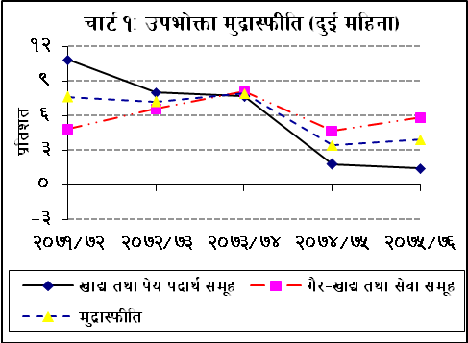
pkef]Qmf d'b|f:kmLlt
- @)&% ebf} dlxgfdf jflif{s ljGb'ut pkef]Qmf d'b|f:kmLlt #=( k|ltzt /x]sf] 5 . cl3Nnf] jif{sf]] ;f]xL cjlwdf o:tf] d'b|f:kmLlt #=$ k|ltzt /x]sf] lyof] . u}x|–vfB tyf ;]jf ;d'xsf] d"No j[l4sf sf/0f ;dLIff cjlwdf ;du| d'b|f:kmLltdf s]xL bjfj l;h{gf x'g uPsf] xf] .
vfB tyf k]o kbfy{ d'b|f:kmLlt
- @)&% ebf} dlxgfdf vfB tyf k]o kbfy{ ;d'xsf] d'b|f:kmLlt !=$ k|ltzt /x]sf] 5 . cl3Nnf] jif{sf]] ;f]xL cjlwdf pQm ;d'xsf] d'b|f:kmLlt !=* k|ltzt /x]sf] lyof] . vf;u/L bnxg tyf u]8fu'8L, t/sf/L Pjd\ lrgLhGo j:t'sf] d"Nodf cfPsf] lu/fj6sf sf/0f ;dLIff cjlwdf ;du| vfB tyf k]o kbfy{sf] d'b|f:kmLlt cl3Nnf] jif{sf] t'ngfdf sd ePsf] xf] .
u}/–vfB tyf ;]jf d'b|f:kmLlt
- ;dLIff cjlwdf u}/–vfB tyf ;]jf ;d'xsf] d'b|f:kmLlt %=* k|ltzt /x]sf] 5 . cl3Nnf] jif{sf]] ;f]xL cjlwdf pQm d'b|f:kmLlt $=& k|ltzt /x]sf] lyof] . o; ;d"x cGtu{t oftfoft, kmlg{l;ª, 3/fo;L pks/0f Pjd\ sk8f tyf h'QfrKkn nufotsf j:t' tyf ;]jfx?sf] d"No a9]sf sf/0f ;du| u}/–vfB tyf ;]jf d'b|f:kmLlt j[l4 ePsf] xf] .
If]qut pkef]Qmf d'b|f:kmLlt
- @)&% ebf} dlxgfdf pkef]Qmf d'b|f:kmLlt kxf8df %=) k|ltzt, t/fO{df #=& k|ltzt, lxdfndf #=$ k|ltzt / sf7df8f}+ pkTosfdf #=) k|ltzt /x]sf] 5 . cl3Nnf] jif{sf] ;f]xL cjlwdf o:tf] d'b|f:kmLlt kxf8df #=$ k|ltzt, t/fO{df #=* k|ltzt, lxdfndf %=$ k|ltzt / sf7df8f}+ pkTosfdf @=* k|ltzt /x]sf] lyof] .
g]kfn / ef/tsf] pkef]Qmf d'b|f:kmLlt
- @)&% ebf} dlxgfdf g]kfnsf] jflif{s laGb'ut pkef]Qmf d'b|f:kmLlt #=( k|ltzt / ef/tsf] #=* k|ltzt /x]sf] 5 . cl3Nnf] jif{sf] ;f]xL cjlwdf g]kfnsf] d'b|f:kmLlt #=$ k|ltzt / ef/tsf] #=# k|ltzt /x]sf] lyof] .
yf]s d'b|f:kmLlt
- @)&% ebf} dlxgfdf jflif{s laGb'ut yf]s d'b|f:kmLlt *=& k|ltzt /x]sf] 5 . cl3Nnf] jif{sf]] ;f]xL cjlwdf o:tf] d'b|f:kmLlt !=% k|ltzt /x]sf] lyof] . vf;u/L k]6«f]lnod kbfy{, cfwf/e"t wft' tyf sk8f nufotsf j:t'x?sf] d"Nodf ePsf] j[l4sf sf/0f ;du| yf]s d'b|f:kmLlt a9\g uPsf] xf] .
/fli6«o tnj tyf Hofnfb/ ;"rsfÍ
- ;dLIff cjlwdf jflif{s laGb'ut /fli6«o tna tyf Hofnfb/ ;"rsfÍ *=# k|ltztn] j[l4 ePsf]
5 . cl3Nnf] jif{sf] ;f]xL cjlwdf pQm ;"rsfÍ %=) k|ltztn] j[l4 ePsf] lyof] . ;dLIff cjlwdf tna ;"rsfÍ ^=^ k|ltzt / Hofnfb/ ;"rsfÍ *=* k|ltztn] j[l4 ePsf] 5 .
afXo If]q
j}b]lzs Jofkf/
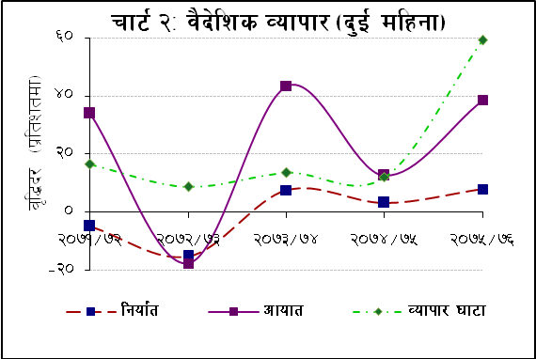
- cfly{s jif{ @)&%÷&^ sf] b'O{ dlxgfdf s'n j:t' lgof{t * k|ltztn] j[l4 eO{ ?=!$ ca{ &) s/f]8 k'u]sf] 5 . cl3Nnf] jif{sf] ;f]xL cjlwdf o:tf] lgof{tdf #=@ k|ltztn] j[l4 ePsf]] lyof] . uGtAosf cfwf/df ef/ttkm{ !#=^ k|ltzt, rLgtkm{ !!=$ k|ltzt / cGo d'n'stkm{ !=) k|ltztn] lgof{t j[l4 ePsf] 5 . j:t'ut cfwf/df kf]lni6/ ofg{, h:tfkftf, bGt d~hg, nQfsk8f, h';, nufotsf j:t'sf] lgof{t a9]sf] 5 eg] tof/L kf]zfs, h'6sf ;fdfg, /f]lhg, cn}+rL, klZdgf, nufotsf j:t'x?sf] lgof{t 36]sf] 5 .
- ;dLIff cjlwdf s'n j:t' cfoft #*=% k|ltztn] a9]/ ?=@#@ ca{ #% s/f]8 k'u]sf] 5 . cl3Nnf] jif{sf] ;f]xL cjlwdf o:tf] cfoft !@=^ k|ltztn] a9]sf] lyof] . j:t' cfoft ul/g] d'n'ssf cfwf/df ef/taf6 ePsf] cfoft #*=( k|ltzt, rLgaf6 ePsf] cfoft !#=@ k|ltzt / cGo d'n'saf6 ePsf] cfoft %%=@ k|ltztn] a9]sf] 5 . j:t'ut cfwf/df k]6«f]lnod kbfy{, xjfO{hxfhsf kf6{k"hf{, Pd=P;= lan]6, ;jf/L ;fwg tyf kf6{k"hf{, cGo d]lzg/L tyf kf6{k'hf{ nufotsf j:t'sf] cfoft a9]sf] 5 eg] b'/;~rf/sf pks/0f tyf kf6{k'hf{, l;d]G6, :jf:y ;DaGwL pks/0f tyf cf}hf/, lel8of] 6]lnlehg tyf kf6{k'hf{, oftfoftsf ;fwg tyf kf6{k"hf{ nufotsf j:t'x?sf] cfoft 36]sf] 5 .
- eG;f/ gfsfsf cfwf/df e}/xjf eG;f/ sfof{no, lj/f6gu/ eG;f/ sfof{no, lqe'jg ljdfg:yn eG;f/ sfof{no, d]rL eG;f/ sfof{no / /;'jf eG;f/ sfof{noaf6 ul/Psf] lgof{tdf j[l4 ePsf] 5 eg] g]kfnu~h, jL/u~h ;'Vvf jGb/ufxf eG;f/ sfof{no, s[i0fgu/ tyf s}nfnL eG;f/ gfsfx¿af6 ul/Psf] lgof{tdf eg] x|f; cfPsf]] 5 . To;}u/L, cfofttkm{ ;dLIff cjlwdf jL/u~h eG;f/ sfof{no, ;'Vvf aGb/ufxf eG;f/ sfof{no, e}/xjf eG;f/ sfof{no, lj/f6gu/ eG;f/ sfof{no, lqe'jg ljdfg:yn eG;f/ sfof{no, g]kfnu~h eG;f/ sfof{no, d]rL eG;f/ sfof{no, s[i0fgu/ eG;f/ sfof{no, s}nfnL eG;f/ sfof{no, hn]Zj/ eG;f/ sfof{no / /;'jf eG;f/ sfof{noaf6 ePsf] cfoftdf j[l4 ePsf]] 5 eg] cGo gfsfaf6 ePsf] cfoftdf sdL cfPsf]] 5 .
- ;dLIff cjlwdf s'n j:t' Jofkf/ 3f6f $!=@ k|ltztn] lj:tf/ eO{ ?=@!& ca{ ^% s/f]8 k'u]sf] 5 . ;dLIff cjlwdf lgof{t–cfoft cg'kft ^=# k|ltzt sfod ePsf] 5, h''g cl3Nnf] jif{sf] ;f]xL cjlwdf *=! k|ltzt /x]sf] lyof] .
;]jf
- ;dLIff cjlwdf s'n ;]jf cfodf @^=( k|ltzt / s'n ;]jf vr{ #%=* k|ltztn] a9]sf] sf/0f v'b ;]jf cfo ?=!! ca{ @ s/f]8n] 3f6fdf uPsf] 5 . cl3Nnf] jif{sf] ;f]xL cjlwdf v'b ;]jf cfo ?=^ ca{ &) s/f]8n] 3f6fdf /x]sf] lyof] .
- ;]jf vftf cGt{ut ko{6g cfo ;dLIff cjlwdf !@=( k|ltztn] dfq j[l4 eO{ ?=( ca{ !^ s/f]8 k'u]sf] 5 . cl3Nnf] jif{sf] ;f]xL cjlwdf o:tf] cfo *=@ k|ltztn] a9]sf] lyof] .
ljk|]if0f cfk|jfx
- ;dLIff cjlwdf ljk|]if0f cfk|jfx ##=$ k|ltztn] j[l4 eO{ ?=!%$ ca{ @) s/f]8 k'u]sf] 5 . cl3Nnf] jif{sf] ;f]xL cjlwdf ljk|]if0f cfk|jfx )=& k|ltztn] a9]sf] lyof] . cd]l/sL 8n/df ljk|]if0f cfk|jfx @@=# k|ltztn] j[l4 ePsf] 5 . cl3Nnf] jif{ o:tf] cfk|jfx %=@ k|ltztn] a9]sf] lyof] .
tflnsf !M j}b]lzs /f]huf/L hfg] g]kfnLx¿sf] ;+Vof
-b'O{ dlxgf_
s_ ;+:yfut tyf JolQmut -gofF / j}Bflgs/0f_
sfdbf/sf] ;+Vof |  |  | k|ltzt lx:;f
b]z | 2074/75 | 2075/76 | 2074/75 | 2075/76
stf/ | 14733 | 14278 | 22.6 | 37.1
;+o'Qm c/a O{ld/]6\; | 10330 | 9018 | 15.8 | 23.5
;fpbL c/j | 8868 | 4905 | 13.6 | 12.8
s'j]t | 2186 | 2906 | 3.4 | 7.6
dn]l;of | 23362 | 2302 | 35.8 | 6.0
ax/fOg | 711 | 841 | 1.1 | 2.2
cf]dfg | 529 | 444 | 0.8 | 1.2
ckmuflg:tfg | 398 | 192 | 0.6 | 0.5
hfkfg | 110 | 91 | 0.2 | 0.2
blIf0f sf]l/of | 1352 | 15 | 2.1 | 0.0
Oh/fon | 7 | 9 | 0.0 | 0.0
n]jgfg | 2 | 0 | 0.0 | 0.0
cGo | 2599 | 3449 | 4.0 | 9.0
s'n | 65187 | 38450 | 100.0 | 100.0
k|ltzt kl/jt{g | -7.2 | -41.0 | - | -
v_ k'g >d :jLs[lt
k'g >d :jLs[lt | 32271 | 29101 | - | -
k|ltzt kl/jt{g | 6.9 | -9.8 | - | -
;|f]tM j}b]lzs /f]huf/ ljefu
- ;dLIff cjlwdf v'b 6«fG;km/ cfo #$=! k|ltztn] j[l4 eO{ ?=!&% ca{ # s/f]8 k'u]sf] 5 . cl3Nnf] jif{sf] ;f]xL cjlwdf o:tf] cfo )=# k|ltztn] a9]sf] lyof] .
- clGtd >d :jLs[ltsf cfwf/df j}b]lzs /f]huf/Ldf hfg] g]kfnLsf] ;+Vof ;dLIff cjlwdf $! k|ltztn] 36]sf] 5 . cl3Nnf] jif{sf] ;f]xL cjlwdf o:tf] ;+Vof &=@ k|ltztn] 36]]sf] lyof] .
rfn" vftf Pjd\ zf]wgfGt/ l:ylt
- j:t' cfoftdf ePsf] pRr j[l4sf sf/0f ;dLIff cjlwdf rfn" vftf 3f6f lj:tf/ eO{ ?=#% ca{ %^ s/f]8 k'u]sf] 5 . cl3Nnf] jif{sf] ;f]xL cjlwdf o:tf] 3f6f ?=!( ca{ &$ s/f]8 /x]sf] lyof] . cd]l/sL 8n/df cl3Nnf] jif{sf] b'O{ dlxgf !( s/f]8 @^ nfv 8n/ /x]sf] rfn' vftf 3f6f ;dLIff cjlwdf #@ s/f]8 ! nfv 8n/ k'u]sf] 5 .
- ;dLIff cjlwdf zf]wgfGt/ 3f6f ?=@% ca{ $% s/f]8 /x]sf] 5 . o:tf] 3f6f cl3Nnf] jif{sf] ;f]xL cjlwdf ?=% ca{ *& s/f]8 /x]sf] lyof] . cd]l/sL 8n/df zf]wgfGt/ 3f6f cl3Nnf] jif{sf] b'O{ dlxgfdf % s/f]8 &# nfv 8n/ /x]sf]df ;dLIff cjlwdf @# s/f]8 ( nfv 8n/ /x]sf] 5 .
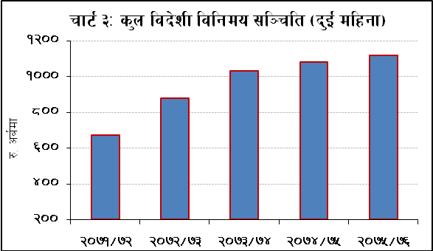
- ;dLIff cjlwdf k"FhLut 6«fG;km/ ?=@ ca{ *) s/f]8 / k|ToIf j}b]lzs nufgL cfk|jfx
?=! ca{ @# s/f]8 /x]sf] 5 . cl3Nnf] jif{sf] ;f]xL cjlwdf k"FhLut 6«fG;km/ ?=! ca{ *$ s/f]8 / k|ToIf j}b]lzs nufgL ?=% ca{ !) s/f]8 /x]sf] lyof] .
ljb]zL ljlgdo ;l~rlt
- s'n ljb]zL ljlgdo ;l~rlt @)&% c;f/ d;fGtsf] ?=!!)@ ca{ %( s/f]8af6 !=# k|ltztn] j[l4 eO{ @)&% ebf} d;fGtdf ?=!!!& ca{ $^ s/f]8 k'u]sf] 5 . cd]l/sL 8n/df o:tf] ;l~rlt @)&% c;f/ d;fGtsf] ?=!) ca{ * s/f]8af6 #=$ k|ltztn] sdL cfO{ @)&% ebf} d;fGtdf ?=( ca{ &% s/f]8 k'u]sf] 5 .
- s'n ljb]zL ljlgdo ;l~rltdWo] g]kfn /fi6« a}+sdf /x]sf] ;l~rlt @)&% c;f/ d;fGtsf] ?=(*( ca{ $) s/f]8sf] t'ngfdf @)&% ebf} d;fGtdf @=@ k|ltztn] sdL cfO{ ?=(^& ca{ (# s/f]8 k'u]sf] 5 . csf]{tkm{, a}+s tyf ljQLo ;+:yfx¿ -g]kfn /fi6« a}+s afx]s_ ;Fu /x]sf] ljb]zL ljlgdo ;l~rlt @)&% c;f/ d;fGtdf ?=!!# ca{ !( s/f]8 /x]sf]df @)&% ebf} d;fGtdf #@=! k|ltztn] j[l4 eO{ ?=!$( ca{ %# s/f]8 k'u]sf] 5 . @)&% ebf} d;fGtsf] s'n ljb]zL ljlgdo ;l~rltdf ef/tLo d'b|fsf] c+z @#=^ k|ltzt /x]sf] 5 .
;l~rlt kof{Kttf ;"rsx¿
- cfly{s jif{ @)&%÷&^ sf] b'O{ dlxgfsf] cfoftnfO{ cfwf/ dfGbf a}lsË If]q;Fu /x]sf] ljb]zL ljlgdo ;l~rltn] (=& dlxgfsf] j:t' cfoft / *=# dlxgfsf] j:t' tyf ;]jf cfoft wfGg kof{Kt /xg] b]lvG5 . ;dLIff cjlwdf ljb]zL ljlgdo ;l~rltsf] s'n ufx{:Yo pTkfbg, s'n cfoft / lj:t[t d'b|fk|bfo;Fusf cg'kftx¿ qmdzM #&=@ k|ltzt, ^(=% k|ltzt / #^=! k|ltzt /x]sf 5g\ . @)&% c;f/ d;fGtdf o:tf cg'kftx¿ qmdzM #^=& k|ltzt, &*=^ k|ltzt / #%=^ k|ltzt /x]sf lyP .
sRrf k]6«f]lnod Pjd\ ;'gsf] d"No
- cGt/f{li6«o ahf/df sRrf k]6«f]lnod (Crude Oil Brent) sf] d"No @)&$ ebf} d;fGtdf k|lt Aof/n cd]l/sL 8n/ %^=!* /x]sf]df @)&% ebf} d;fGtdf #*=^ k|ltztn] j[l4 eO{ k|lt Aof/n cd]l/sL 8n/ &&=*& k'u]sf] 5 . csf]{tkm{, ;'gsf] d"No @)&$ ebf} d;fGtdf k|lt cfpG; cd]l/sL 8n/ !#@@=*% /x]sf]df @)&% ebf} d;fGtdf (=! k|ltztn] sdL cfO{ k|lt cfpG; cd]l/sL 8n/ !@)# sfod ePsf] 5 .
ljlgdo b/
- @)&% c;f/ d;fGtsf] t'ngfdf @)&% ebf} d;fGtdf g]kfnL ¿k}ofF cd]l/sL 8n/;Fu $=^ k|ltztn] cjd"Nog ePsf] 5 . cl3Nnf] jif{sf] ;f]xL cjlwdf g]kfnL ?k}ofF )=^ k|ltztn] clwd"Nog ePsf] lyof] . @)&% ebf} d;fGtdf cd]l/sL 8n/ Pssf] vl/b ljlgdo b/ ?=!!$=^^ k'u]sf] 5 . @)&% c;f/ d;fGtdf pQm ljlgdo b/ ?=!)(=#$ /x]sf] lyof] .
;/sf/L ljQ l:ylt↓
ah]6 3f6f÷art
Tflnsf @M cfly{s jif{ @)&%÷&^ sf] ah]6sf] k|ult
-?= ca{df_
zLif{s | ah]6  cg'dfg | b'O{  dlxgfsf]  k|ult* | ah]6  cg'dfgsf]  -k|ltztdf_
s'n vr{ | 1315.2 | 66.3 | 5.0
rfn" vr{ | 845.4 | 61.5 | 7.3
k'FhLut vr{ | 314.0 | 4.1 | 1.3
ljQLo Joj:yf vr{ | 155.7 | 0.7 | 0.4
/fh:j | 945.6 | 119.2 | 12.6
* gub k|jfxdf cfwfl/t
- cfly{s jif{ @)&%÷&^ sf] b'O{ dlxgfdf gub k|jfxdf cfwfl/t g]kfn ;/sf/sf] ah]6 ?=%% ca{ (# s/f]8n] artdf /x]sf] 5 . cl3Nnf] jif{sf] ;f]xL cjlwdf o:tf] art ?=!( ca{ !* s/f]8 /x]sf] lyof] .
;/sf/L vr{
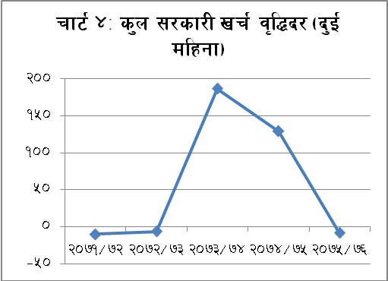
- ;dLIff cjlwdf gub k|jfxdf cfwfl/t s'n ;/sf/L vr{ ?=^^ ca{ ## s/f]8 k'u]sf] 5 . cl3Nnf] jif{sf] ;f]xL cjlwdf o:tf] vr{ ?=&@ ca{ #* s/f]8 /x]sf] lyof] .
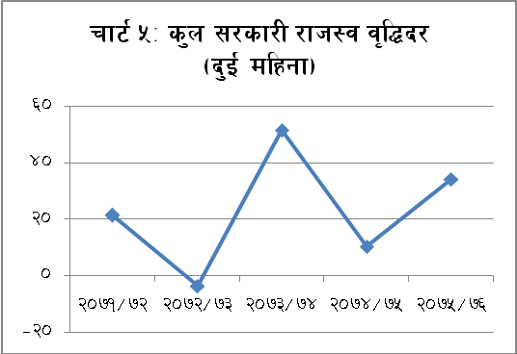
- ;dLIff cjlwdf rfn" vr{ ?=^! ca{ %! s/f]8 k'u]sf]] 5 . cl3Nnf] jif{sf] ;f]xL cjlwdf o:tf] vr{ ?=&) ca{ @^ s/f]8 /x]sf] lyof] . ;dLIff cjlwdf ?=$ ca{ !$ s/f]8 k"FhLut vr{ ePsf] 5 . cl3Nnf] jif{sf] ;f]xL cjlwdf o:tf] vr{ ?=! ca{ %% s/f]8 ePsf] lyof] .
;/sf/L /fh:j
- ;dLIff cjlwdf g]kfn ;/sf/sf] s'n /fh:j ;Íng #$=# k|ltztn] j[l4 eO{ ?=!!( ca{ @) s/f]8 k'u]sf]] 5 . cl3Nnf] jif{sf] ;f]xL cjlwdf o:tf] /fh:j !)=# k|ltztn] j[l4 eO{ ?=** ca{ &( s/f]8 k'u]sf] lyof] .
;/sf/sf] gub df}Hbft
- @)&% ebf} d;fGtdf ;/sf/L 9's'6Ldf ?=@)! ca{ $% s/f]8 gub df}Hbft sfod /x]sf] 5 .
df}lb|s l:ylt
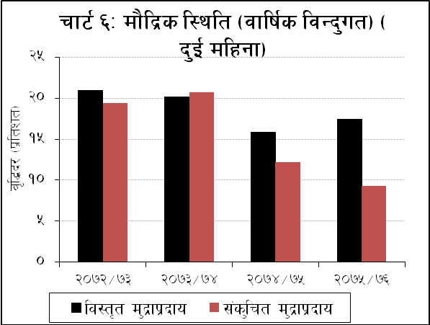
d'b|fk|bfo
- cfly{s jif{ @)&%÷&^ sf] b'O{ dlxgfdf lj:t[t d'b|fk|bfo )=! k|ltztn] a9]sf] 5 . cl3Nnf] jif{sf] ;f]xL cjlwdf pQm d'b|fk|bfo !=* k|ltztn] a9]sf] lyof] . jflif{s laGb'ut cfwf/df @)&% ebf} d;fGtdf lj:t[t d'b|fk|bfo !&=$ k|ltztn] a9]sf] 5 .
- ;dLIff cjlwdf v'b j}b]lzs ;DklQ -ljb]zL ljlgdo d"NofÍg gfkmf÷gf]S;fg ;dfof]lht_ ?=@% ca{ $% s/f]8 -@=$ k|ltzt_ n]] 36]sf] 5 . cl3Nnf] jif{sf] ;f]xL cjlwdf pQm ;DklQ ?=% ca{ *& s/f]8 -)=^ k|ltzt_ n] 36]sf] lyof] .
- ;dLIff cjlwdf ;l~rt d'b|f !)=! k|ltztn] 36]sf]]] 5 . cl3Nnf] jif{sf] ;f]xL cjlwdf o:tf] d'b|f !#=# k|ltztn] 36]sf] lyof] . jflif{s laGb'ut cfwf/df @)&% ebf} d;fGtdf ;l~rt d'b|f !@=! k|ltztn] a9]sf] 5 .
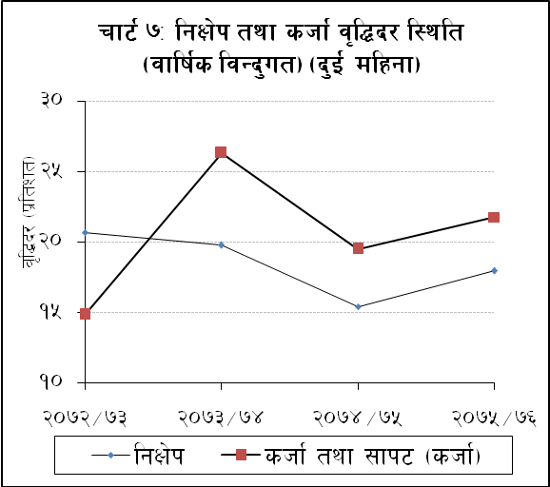
s'n cfGtl/s shf{
- ;dLIff cjlwdf s'n cfGtl/s shf{ !=! k|ltztn] a9]sf] 5 . cl3Nnf] jif{{sf] ;f]xL cjlwdf pQm shf{ !=& k|ltztn] 36]sf] lyof] . jflif{s laGb'ut cfwf/df @)&% ebf} d;fGtdf o:tf] shf{ @*=$ k|ltztn] a9]sf] 5 .
- ;dLIff cjlwdf df}lb|s If]qsf] lghL If]qdflysf] bfjL #=@ k|ltztn] a9]sf] 5 . cl3Nnf] jif{sf] ;f]xL cjlwdf klg o:tf] bfjL #=@ k|ltztn] g} a9]sf] lyof] . jflif{s laGb'ut cfwf/df df}lb|s If]qsf] lghL If]qdflysf] bfjL @)&% ebf} d;fGtdf @@=# k|ltztn] a9]sf] 5 .
lgIf]k ;+sng
- ;dLIff cjlwdf a}+s tyf ljQLo ;+:yfx¿df /x]sf] lgIf]k !=# k|ltztn] a9]sf] 5 . cl3Nnf] jif{{sf] ;f]xL cjlwdf o:tf] lgIf]k @=$ k|ltztn] a9]sf] lyof] . jflif{s laGb'ut cfwf/df @)&% ebf} d;fGtdf a}+s tyf ljQLo ;+:yfx¿sf] lgIf]k !&=( k|ltztn] a9]sf] 5 .
- @)&% ebf}df a}+s tyf ljQLo ;+:yfx¿sf] s'n lgIf]kdf rlNt, art / d'2tLsf] c+z qmdzM &=( k|ltzt, #$=@ k|ltzt / $%=& k|ltzt /x]sf] 5 . cl3Nnf] jif{{sf] ;f]xL dlxgfdf o:tf] c+z qmdzM *=# k|ltzt, #%=^ k|ltzt / $#=! k|ltzt /x]sf] lyof] .
- @)&% ebf}df a}+s tyf ljQLo ;+:yfx?sf] s'n lgIf]kdf ;+:yfut lgIf]ksf] c+z $$=& k|ltzt /x]sf] 5 . cl3Nnf] jif{sf] ;f]xL dlxgfdf o:tf] lgIf]ksf] c+z $#=& k|ltzt /x]sf] lyof] .

shf{ k|jfx
- ;dLIff cjlwdf a}+s tyf ljQLo ;+:yfx?af6 lghL If]qdf k|jflxt shf{ @=) k|ltztn] a9]sf] 5 . cl3Nnf] jif{sf] ;f]xL cjlwdf o:tf] shf{ @=! k|ltztn] a9]sf] lyof] . lghL If]qtk{m k|jflxt shf{dWo] ;dLIff cjlwdf jfl0fHo a}+sx?sf] shf{ k|jfx @=) k|ltztn], ljsf; a}+sx?sf] @=& k|ltztn] / ljQ sDkgLx?sf] )=% k|ltztn] a9]sf] 5 . jflif{s laGb'ut cfwf/df @)&% ebf} d;fGtdf a}+s tyf ljQLo ;+:yfx¿af6 lghL If]qtk{m k|jflxt shf{ @@=$ k|ltztn] a9]sf] 5 .
- @)&% ebf} d;fGtdf a}+s tyf ljQLo ;+:yfx¿sf] nufgLdf /lx/x]sf] shf{dWo] ^#=! k|ltzt shf{ 3/ hUufsf] lwtf]df / !$=# k|ltzt shf{ rfn" ;DklQ -s[lif tyf u}/–s[lifhGo j:t'_ sf] lwtf]df k|jfx ePsf] 5 . @)&$ ebf} d;fGtdf o:tf] lwtf]df k|jflxt shf{sf] cg'kft qmdzM ^)=( k|ltzt / !$=@ k|ltzt /x]sf] lyof] .
- ;dLIff cjlwdf a}+s tyf ljQLo ;+:yfx?af6 k|jflxt cfjlws shf{ %=) k|ltztn], cf]e/8«fˆ6 shf{ )=% k|ltztn], 6«i6 l/l;K6 -cfoft_ shf{ ^=@ k|ltztn], l8dfG8 tyf rfn' k"FhL shf{ %=% k|ltztn], l/on :6]6 shf{ -JolStut cfjf;Lo 3/ shf{ ;d]t_ @=@ k|ltztn] tyf xfo/ kr]{h shf{ @=! k|ltztn] a9]sf] 5 eg] dflh{g k|s[lt shf{ )=( k|ltztn] 36]sf] 5 .
t/ntf Joj:yfkg
- cfly{s jif{ @)&%÷&^ sf] b'O{ dlxgfdf v'nfahf/ sf/f]af/sf ljleGg pks/0fx?dfk{mt\ k6s–k6s u/L ?=*% ca{ #% s/f]8 t/ntf k|zf]rg ul/Psf] 5 . o; cg';f/ lgIf]k ;+sng af]nsaf]ndfkm{t\ ?=&( ca{ ^% s/f]8 / l/e;{ l/kf]dfk{mt\ ?=% ca{ &) s/f]8 k|zf]rg ePsf] 5 .
- ;dLIff cjlwdf o; a}+sn] ljb]zL ljlgdo ahf/ -jfl0fHo a}+sx¿_ af6 cd]l/sL 8n/ @& s/f]8 (( nfv v'b vl/b u/L ?=#! ca{ $& s/f]8 v'b t/ntf k|jfx u/]sf] 5 . cl3Nnf] jif{sf] ;f]xL cjlwdf ljb]zL ljlgdo ahf/af6 cd]l/sL 8n/ %! s/f]8 $# nfv v'b vl/b u/L ?=%@ ca{ &) s/f]8 v'b t/ntf k|jfx ul/Psf] lyof] .
- ;dLIff cjlwdf cd]l/sL 8n/ &@ s/f]8, o"/f] ! s/f]8 ^) nfv / kfp08 :6ln{Ë @ s/f]8 laqmL u/L ?=*% ca{ ^^ s/f]8 a/fa/sf] ef=?= vl/b ePsf] 5 . cl3Nnf] jif{sf] ;f]xL cjlwdf cd]l/sL 8n/ ^@ s/f]8 laqmL u/L ?=^# ca{{ %^ s/f]8 a/fa/sf] ef=?= vl/b ePsf] lyof] .
k'g/shf{
- pTkfbgzLn If]qtk{m nufgL tyf lgof{t lj:tf/df ;d]t ;xof]u k'¥ofpg] p2]Zon] o; a}+saf6 ;x'lnot b/df k|bfg ul/g] k'g/shf{sf] pkof]u ;dLIff cjlwdf a9]sf] 5 . @)&% ebf} d;fGtdf ?=!% ca{ *# s/f]8 o; a}+sn] k|bfg u/]sf] k'g/shf{ nufgLdf /x]sf] 5 .
- e"sDk kLl8tx¿nfO{ a9Ldf @=) k|ltzt;Ddsf] Aofhb/df cfjf;Lo 3/ lgdf{0f shf{ k|bfg ug{ o; a}+saf6 a}+s tyf ljQLo ;+:yfx?nfO{ z"Go Aofhb/df k'g/shf{ ;'ljwf pknAw u/fpg] Joj:Yff cGtu{t @)&% ebf} d;fGt;Dddf ?=@ ca{ !* s/f]8 k'g/shf{ pkof]udf /x]sf] 5 . o:tf] shf{ !@#! hgfn] pkof]u u/]sf 5g\ .
- @)&% ebf} d;fGt;Dddf g]kfn ;/sf/af6 % k|ltzt Aofh cg'bfgdf k|jfx ul/g] s[lif tyf kz'k+IfL Joj;fo shf{ *(#) hgfn] pkof]u u/]sf 5g\ . o; cGtu{t ?=!) ca{ ^^ s/f]8 shf{ aSof}tf /x]sf] 5 eg] ?=%( s/f]8 ^^ nfv Aofh cg'bfg k|bfg ul/Psf] 5 .
cGt/–a}+s sf/f]af/
- cfly{s jif{ @)&%÷&^ sf] b'O{ dlxgfdf jfl0fHo a}+sx¿n] ?=@)( ca{ * s/f]8 / cGo ljQLo ;+:yfx¿ -jfl0fHo a}+sx¿aLr afx]s_ n] ?=!% ca{ $! s/f]8sf] cGt/–a}+s sf/f]af/ u/]sf 5g\ . cl3Nnf] jif{sf] ;f]xL cjlwdf jfl0fHo a}+sx¿ / cGo ljQLo ;+:yfx¿n] qmdzM ?=(# ca{ (# s/f]8 / ?=& ca{ * s/f]8sf] o:tf] sf/f]af/ u/]sf lyP .
Aofhb/
- @)&$ ebf}df (!–lbg] 6«]h/L ljnsf] efl/t cf};t Aofhb/ )=$* k|ltzt /x]sf]df @)&% ebf}df @=&$ k|ltzt sfod ePsf] 5 . jfl0fHo a}+sx¿aLrsf] cGt/–a}+s sf/f]af/sf] efl/t cf};t Aofhb/ eg] @)&$ ebf}sf] )=#( k|ltztsf] t'ngfdf @)&% ebf}df !=^* k|ltzt /x]sf] 5 . To;}u/L, jfl0fHo a}+sx¿sf] cf};t cfwf/ Aofhb/ @)&$ ebf}sf] !)=!# k|ltztsf] t'ngfdf @)&% ebf}df !)=)# k|ltzt sfod ePsf] 5 .
dh{/÷ k|flKt
- o; a}+sn] a}+s tyf ljQLo ;+:yf ufEg]÷ufleg] tyf k|flKt ;DaGwL k|lqmof z'? u/fPkZrft\ @)&% ebf} d;fGt;Dd s'n !^$ j6f a}+s tyf ljQLo ;+:yfx¿ dh{/÷k|flKt k|lqmofdf ;fd]n ePsf 5g\ . o;dWo] !@@ j6f ;+:yfx?sf] Ohfht vf/]h x'g uO{ s'n $@ ;+:yf sfod ePsf 5g\ .
tflnsf #M @)&% ebf} d;fGt;Dd jfl0fHo a}+sx?sf] pkl:ylt ePsf :yfgLo tx
k|b]z | :yfgLo txsf] ;+Vof | jfl0fHo a}+sx?sf] pkl:ylt ePsf :yfgLo tx
k|b]z ! | 137 | 118
k|b]z @ | 136 | 130
k|b]z # | 119 | 108
k|b]z $ | 85 | 80
k|b]z % | 109 | 106
k|b]z ^ | 79 | 59
k|b]z & | 88 | 65
s'n | 753 | 666
ljQLo kx'Fr
- ;+3Lotf sfof{Gjogsf] qmddf u7g ePsf &%# :yfgLo txx?dWo] @)&% ebf} d;fGt;Dd ^^^ :yfgLo txx?df jfl0fHo a}+sx?sf] pkl:ylt /x]sf] 5 . k|b]zut ?kdf jfl0fHo a}+ssf] pkl:ylt tflnsf # df k|:t't ul/Psf] 5 .

- o; a}+saf6 Ohfht k|fKt a}+s tyf ljQLo ;+:yfx?sf] ;+Vof @)&% ebf} d;fGtdf !%! /x]sf] 5 . o; cg';f/ @* jfl0fHo a}+s, ## ljsf; a}+s, @$ ljQ sDkgL / ^^ n3'ljQ ;+:yfx? ;+rfngdf /x]sf 5g\ . a}+s tyf ljQLo ;+:yfx?sf] zfvf ;~hfn @)&% c;f/ d;fGtdf ^^%! /x]sf]df @)&% ebf} d;fGtdf ^*!( k'u]sf] 5 .
tflnsf $M a}+s tyf ljQLo ;+:yfx?sf] ;+Vof÷zfvf ;+Vof
a}+s tyf ljQLo ;+:yfx? | a}+s tyf ljQLo ;+:yfx?sf] ;+Vof |  | a}+s tyf ljQLo ;+:yfx?sf] zfvf ;+Vof
a}+s tyf ljQLo ;+:yfx? | @)&% c;f/ d;fGt | @)&% ebf} d;fGt | @)&% c;f/ d;fGt | @)&% ebf} d;fGt
jfl0fHo a}+s | @* | @* | #)@# | #)(#
ljsf; a}+s | ## | ## | ((# | !)$#
ljQ sDkgL | @% | @$ | !*^ | !*^
n3'ljQ ljQLo ;+:yf | ^% | ^^ | @$$( | @$(&
hDdf | !%! | !%! | ^^%! | ^*!(
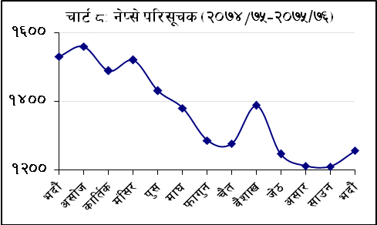
k"”hL ahf/
- g]K;] ;"rsfÍ jflif{s ljGb'ut cfwf/df !&=( k|ltztn] x|f; eO{{ @)&% ebf} d;fGtdf !@%^=% ljGb''df ;Lldt ePsf] 5 . @)&$ ebf} d;fGtdf pQm ;"rsfÍ !%=& k|ltztn] x|f; eO{ !%#)=# ljGb'' sfod ePsf] lyof] . @)&% c;f/ d;fGtdf eg] g]K;] ;"rsfÍ !@!@=$ ljGb' sfod ePsf] lyof] .
- lwtf]kq ahf/ kF"+hLs/0f jflif{s ljGb'ut cfwf/df !%=& k|ltztn] x|f; eO{ @)&% ebf} d;fGtdf ?=!$(^ ca{ ^$ s/f]8 sfod ePsf] 5 . ahf/ k"FhLs/0f @)&$ ebf} d;fGtdf !!=$ k|ltztn] x|f; ePsf] lyof] . ;dLIff cjlwsf] ahf/ k"FhLs/0fsf] s'n ufx{:Yo pTkfbg;Fusf] cg'kft $(=* k|ltzt /x]sf] 5 . cl3Nnf] jif{ o:tf] cg'kft ^&=@ k|ltzt /x]sf] lyof] . ahf/ k"FhLs/0fdf a}+s, ljQLo ;+:yf / aLdf sDkgLx?sf] c+z *)=* k|ltzt /x]sf] 5 eg] hnljB't\ If]qsf] $=@ k|ltzt, pTkfbg tyf k|zf]wg If]qsf] @=& k|ltzt, xf]6nx¿sf] !=& k|ltzt, Jofkfl/s ;+:yfx¿sf] )=! k|ltzt / cGosf] !)=% k|ltzt /x]sf] 5 .
- g]kfn :6s PS;r]Gh lnld6]8df ;"rLs[t sDkgLx¿sf] ;+Vof @)&% ebf} d;fGtdf !(^ /x]sf] 5 . ;"rLs[t sDkgLx¿dWo] !$& j6f a}+s tyf ljQLo ;+:yf -aLdf sDkgL ;d]t_ /x]sf 5g\ eg] !* j6f pTkfbg / k|zf]wg pBf]u, !( j6f hnljB't\ sDkgL, $÷$ j6f xf]6n tyf Jofkfl/s ;+:yf / $ j6f cGo ;d"xsf /x]sf 5g\ .
- g]kfn :6s PS;r]Gh lnld6]8df ;"rLs[t z]o/x¿sf] r'Qmf d"No jflif{s ljGb''ut cfwf/df @!=@ k|ltztn] j[l4 eO{ @)&% ebf}+ d;fGtdf ?=#%* ca{ ! s/f]8 k'u]sf] 5 . ;dLIff cjlwdf ?=! ca{ #% s/f]8 a/fa/sf] ;fwf/0f z]o/, ?=@ ca{ *% s/f]8 a/fa/sf] xsk|b z]o/, ?=$ ca{ * s/f]8 a/fa/sf] af]g; z]o/ u/L s'n ?=* ca{ @* s/f]8 a/fa/sf] yk lwtf]kq ;"rLs[t ePsf 5g\ .

↓ g]kfn /fi6« a}+ssf] ! sfof{no, ;/sf/L sf/f]af/ ug]{ /fli6«o jfl0fHo a}+ssf] *! zfvfx¿, g]kfn a}+s lnld6]8 / PgcfO{;L Pl;of a}+s lnld6]8sf] %^ zfvfx¿, s[lif ljsf; a}+s lnld6]8sf] @^ zfvfx¿, Unf]an cfO{PdO{ a}+s lnld6]8sf] @@ zfvfx¿, Pe/]i6 a}+s lnld6]8 / g]kfn OGe]i6d]G6 a}+s lnld6]8sf] !^÷!^ zfvfx?, PgPdaL a}+s lnld6]8 / d]uf a}+s lnld6]8sf] !!÷!! zfvfx¿, g]kfn a+unfb]z a}+s lnld6]8sf] ( zfvfx?, l;l6h]G; a}+s lnld6]8 / hgtf a}+s lnld6]8sf] &÷& zfvfx¿, l;¢fy{ a}+s lnld6]8sf] ^ zfvfx?, a}s ckm sf7df8f} lnld6]8, glan a}+s lnld6]8 / l;len a}+s lnld6]8sf] %÷% zfvfx? , k|fOd sd{l;on a}+s lnld6]8sf] $ zfvfx?, df5fk'R5|] a}+s lnld6]8, s'df/L a}+s lnld6]8, ;g/fOh a}+s lnld6]8 / k|e' a}+s lnld6]8sf] #÷# zfvfx?, ;]Gr'/L sd{l;on a}+s lnld6]8 / ;flgdf a}+s lnld6]8sf] @÷@ zfvfx? / lhNnfl:yt *! j6} sf]if tyf n]vf lgoGq0f sfof{nox¿ / e'QmfgL s]Gb|x¿af6 k|fKt ljj/0fsf] cfwf/df tof/ ul/Psf] .

